* **Vendor: Microsoft**
* **Exam Code: 70-487**
* **Exam Name: Developing Microsoft Azure and Web Services**
  + **Question 1 -- Question End**

# [Visit PassLeader and Download Full Version 70-487 Exam Dumps](http://www.passleader.com/70-487.html)

## QUESTION 1

You are building an ADO.NET Entity Framework application. You need to validate the conceptual schema definition language (CSDL), store schema definition language (SSDL), and mapping specification language (MSL) files. Which Entity Data Model tool can you use? (Each correct answer presents a complete solution. Choose all that apply.)

|  |  |
| --- | --- |
| A. | EDM Generator (EdmGen.exe) |
| B. | ADO.NET Entity Data Model Designer |
| C. | Entity Data Model Wizard |
| D. | Update Model Wizard |

## Answer:

## QUESTION 2

Drag and Drop Question

You are developing an ASP.NET Web API action method. The action method must return the following JSON in the message body.

{ "Name":"Fabrikam", "Vendor Id":9823, "Items":["Apples", "Oranges"] } You need to return an anonymous object that is serialized to JSON. What should you do? (To answer, drag the appropriate code segments to the correct location or locations in the answer area. Each code segment may be used once, more than once, or not at all. You may need to drag the split bar between panes or scroll to view content.)

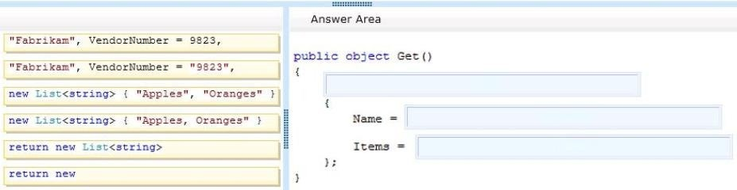

## Answer:

**QUESTION 3**

You are designing an ASP.NET Web API application. You need to select an HTTP verb to allow blog administrators to moderate a comment. Which HTTP verb should you use?

|  |  |
| --- | --- |
| A. | GET |
| B. | POST |
| C. | DELETE |
| D. | PUT |

## Answer:

**QUESTION 4**

Drag and Drop Question

You are developing an ASP.NET Web API application that will be consumed by a web browser via a composite application that is served from another web domain. You need to configure the Web API. What should you do? (To answer, drag the appropriate XML elements to the correct location or locations in the answer area. Each XML element may be used once, more than once, or not at all. You may need to drag the split bar between panes or scroll to view content.)

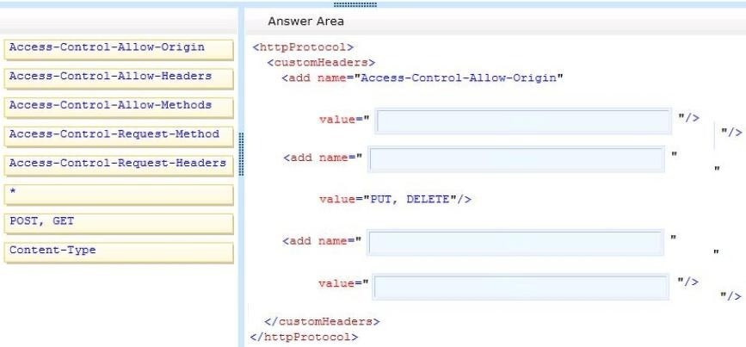

## Answer:

**QUESTION 5**

You are planning to migrate websites from IIS 6 to IIS 7.5. You do not have access to SSH or a VPN. You need to select a deployment tool to securely migrate the websites. Which tool should you use?

|  |  |
| --- | --- |
| A. | RoboCopy |
| B. | Web Deploy |
| C. | Microsoft command-line FTP |
| D. | xCopy |

## Answer:

**QUESTION 6**

Drag and Drop Question

You are developing an ASP.NET MVC Web API application. The method names of the Web API must match naming guidelines for RESTful services. You need to create methods to support standard insert, select, update, and delete operations in an HTTP service. What should you do? (To answer, drag the appropriate HTTP methods to the correct row in the table in the answer area. Each HTTP method may be used once, more than once, or not at all. You may need to drag the split bar between panes or scroll to view content.)

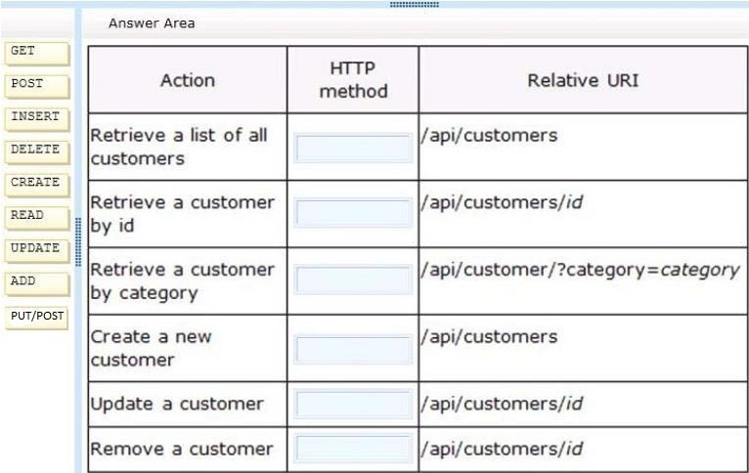

## Answer:

**QUESTION 7**

You are developing an ASP.NET MVC application. Applications can be deployed to remote servers only by administrators who have elevated privileges. The administrators do not have access to Visual Studio 2012. You need to select a deployment tool to deploy the application to remote servers for testing. Which tool should you use?

|  |  |
| --- | --- |
| A. | Copy Web Site Tool |
| B. | One-Click Publish |
| C. | Publish Web Site Tool |
| D. | Web Deployment Package |

## Answer:

**QUESTION 8**

You are developing an ASP.NET MVC web application that contains the following HTML.

<table id= "customer" ></table>

You also have an ASP.NET Web API application that contains a call for retrieving customers. You must send and retrieve the data in the most compact format possible. You need to update the HTML for the customers table to contain data from the Web API application. Which script segment should you use?

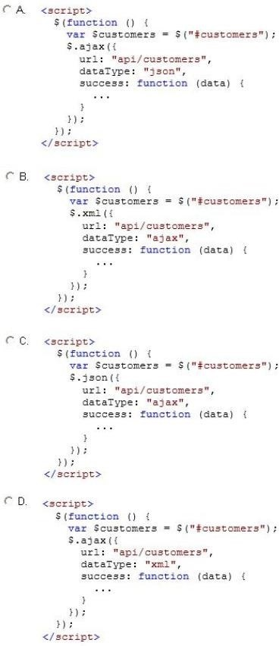

|  |  |
| --- | --- |
| A. | Option A |
| B. | Option B |
| C. | Option C |
| D. | Option D |

## Answer:

**QUESTION 9**

Drag and Drop Question

You are developing an ASP.NET MVC Web API image management application. The application must meet the following requirements:

* It must send or receive image data without the use of a buffer.
* It must allow up to 4 MB of image data to be received.
* It must allow up to 3 MB of image data to be sent.

You need to complete the code to meet the requirements. What should you do? (To answer, drag the appropriate code segments to the correct location or locations in the answer area. Each code segment may be used once, more than once, or not at all. You may need to drag the split bar between panes or scroll to view content.)

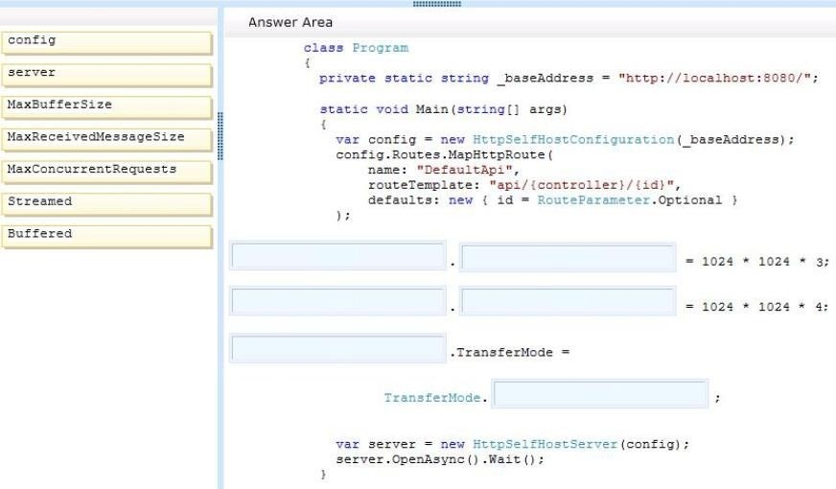

## Answer:

**QUESTION 10**

You are preparing to develop a set of libraries for a company. The libraries must be shared across the company. You need to create a remote NuGet feed that exposes the libraries. What should you do? (Each answer presents part of the solution. Choose all that apply.)

|  |  |
| --- | --- |
| A. | Install the NuGet.Feed Package. |
| B. | Install the NuGet.Server Package. |
| C. | Configure the Packages folder located in the system.webserver section of the web application's Web.config. |
| D. | Create a new Empty Web Site in Visual Studio 2012. |
| E. | Configure the Packages folder located in the appSettings section of the web application's Web.config. |
| F. | Add packages to the Packages folder. |
| G. | Create a new Empty Web Application in Visual Studio 2012. |

**Answer:**

## QUESTION 11

You develop an ASP.NET MVC application that is secured by using SSL. You are ready to deploy the application to production. The deployment package must include the installation of the SSL certificate. You need to configure the deployment package to meet the requirement. What should you do?

|  |  |
| --- | --- |
| A. | Create a web publish pipeline target file with a custom web deploy target. |
| B. | In the Package/Publish settings of the project, select the All Files in this project option. |
| C. | Extend the CopyAllFilesToSingleFolder target in the project file. |
| D. | In the Build Events settings of the project, configure a pre-build event to include the SSL certificate. |

## Answer:

**QUESTION 12**

You are developing a library to support multiple ASP.NET MVC web applications on a shared

server. The library provides implementations of security algorithms. If a problem with any of the security algorithms is discovered, a new version of the library must be created and deployed. Application downtime during the update must be minimized. You need to ensure that the new version of the library will be used by all applications as soon as possible. What should you do?

|  |  |
| --- | --- |
| A. | Build the web applications and include the security assembly as an embedded resource.  When an update is needed, copy the new assembly to the bin directory for the application. |
| B. | Sign all assemblies in each application with the same key used to sign the security assembly. When an update is needed, create a new key pair and re-sign all assemblies. |
| C. | Build the security assembly as a netmodule in a shared location.  Use the assembly linker to merge the netmodule into the assemblies for the application. When an update is needed, update the netmodule in the shared location. |
| D. | Install the security assembly in the Global Assembly Cache (GAC). When an update is needed, update the assembly in the GAC. |

## Answer:

**QUESTION 13**

You are developing an application in Visual Studio 2012 to display student information. The application contains the following Entity Framework model. The application contains a WCF data service named DirectoryService.svc. You need to create a query expression to display all of the grades for students whose first name is "John". How should you build the expression?

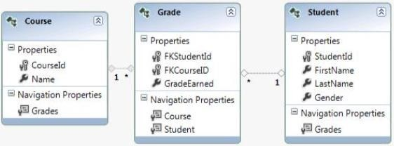

|  |  |
| --- | --- |
| A. | http://localhost:54946/DirectoryService.svc/Students?$filter=FirstName eq 'John' & $expand=Grades |
| B. | http://localhost:54946/DirectoryService.svc/Students?$filter=FirstName eq 'John'/Grades |
| C. | http://localhost:54946/DirectoryService.svc/Students?$filter=FirstName = 'John' & $expand=Grades |
| D. | http://localhost:54946/DirectoryService.svc/Grades/Students?$filter=FirstName eq 'John' |

## Answer:

**QUESTION 14**

Drag and Drop Question

You are developing a WCF Data Services service in Visual Studio 2012 to display movie information from a SQL Server database that changes every 24 hours. The service is defined in the following class.

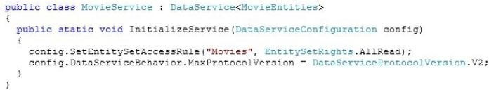

The application contains the following Entity Framework model.

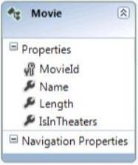

The service must only return data for movies that are currently in theaters. You need to add a method to the MovieService class to filter the data. How should you build the method? (To answer, drag the appropriate code segments to the correct location or locations in the answer area. Each code segment may be used once, more than once, or not at all. You may need to drag the split bar between panes or scroll to view content.)

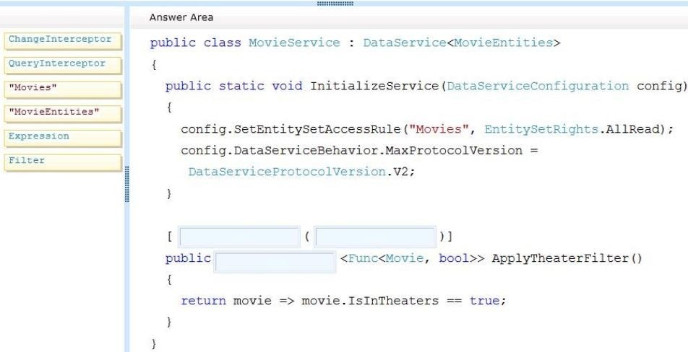

## Answer:

**QUESTION 15**

You are developing an ASP.NET MVC application that reads and writes data from a SQL Server database. You need to prevent the application from reading data that is locked by other transactions. You also need to prevent exclusive range locks. Which isolation level should you use?

|  |  |
| --- | --- |
| A. | ReadCommitted |
| B. | Serializable |
| C. | Repeatable |
| D. | ReadUncommitted |

## Answer:

## QUESTION 16

Drag and Drop Question

You are developing a Windows Azure based web application that provides users the ability to rent training videos. The application is deployed to hosted services in Asia and Europe. The web application must meet the following requirements:

* Video files are large and must be able to be streamed.
* Streaming videos requires low latency network connections.
* Rental data contains structured information about the user and the video.
* Rental permissions are checked every five seconds during video playback. You need to recommend storage architecture for the application. What should you do? (To answer, drag the appropriate technologies to the correct location or locations in the answer area. Each technology may be used once, more than once, or not at all. You may need to drag the split bar between panes or scroll to view content.)

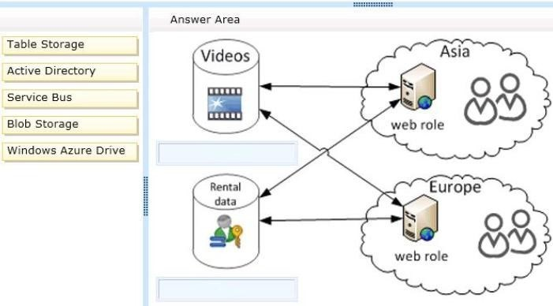

## Answer:

**QUESTION 17**

Drag and Drop Question

You are developing a self-hosted WCF service that returns stock market information. The service must be discoverable by any client application. You need to build the service host. How should you build the host? (To answer, drag the appropriate code segments to the correct location or locations in the answer area. Each code segment may be used once, more than once, or not at all. You may need to drag the split bar between panes or scroll to view content.)

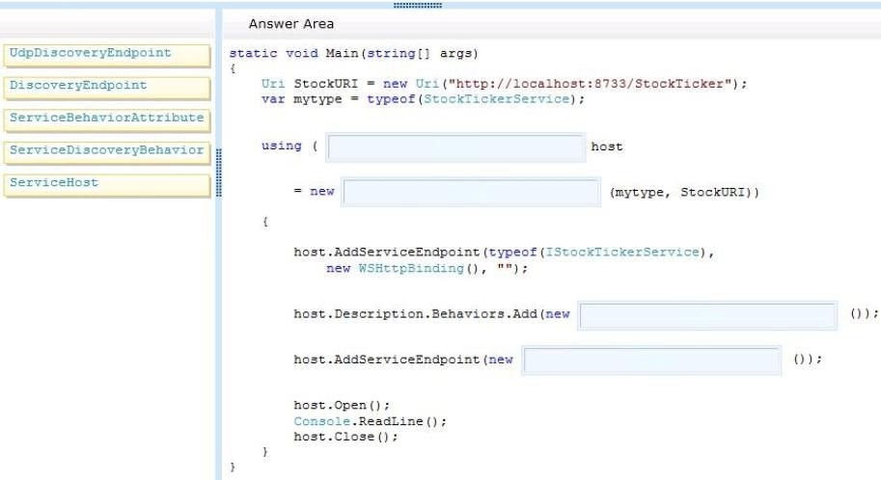

## Answer:

**QUESTION 18**

You are developing a WCF service that compares several data sources. The service takes a long time to complete. The service must meet the following requirements:

* The client must be able to continue processing while the service is running.
* The service must initiate communication with the client application when processing is complete.

You need to choose a message pattern to meet the requirements. Which message pattern should you choose?

|  |  |
| --- | --- |
| A. | One Way |

|  |  |
| --- | --- |
| B. | Streaming |
| C. | Duplex |
| D. | Request/Reply |

## Answer:

**QUESTION 19**

You are developing a WCF service. A new service instance must be created for each client session. You need to choose an instancing mode. Which instance mode should you use?

|  |  |
| --- | --- |
| A. | PerCall |
| B. | Single |
| C. | Multiple |
| D. | PerSession |
| E. | PerRequest |

## Answer:

## QUESTION 20

Drag and Drop Question

You are developing a WCF service. You need to implement transport security by using NTLM authentication and NetTcpBindings. Which configuration values should you use? (To answer, drag the appropriate configuration values to the correct location or locations in the answer area. Each configuration value may be used once, more than once, or not at all. You may need to drag the split bar between panes or scroll to view content.)

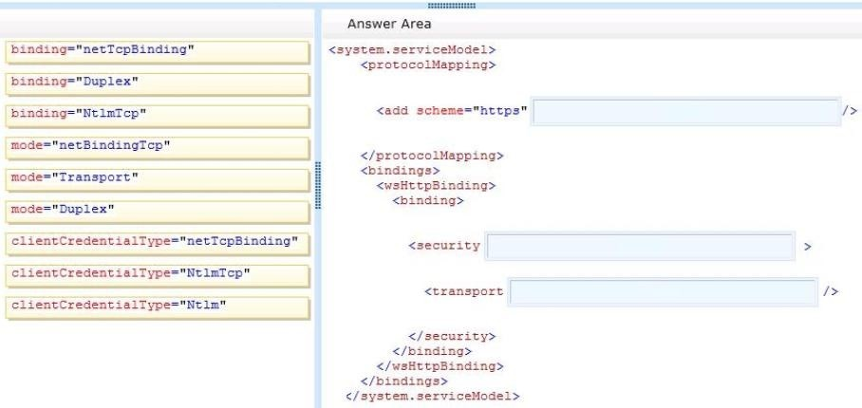

## Answer:

## QUESTION 21

Drag and Drop Question

You are developing a WCF service. The service will stream messages to clients on the internal network. You must use Windows Authentication, and all messages must be binary encoded. You need to configure the service. What should you do? (To answer, drag the appropriate elements to the correct location or locations in the answer area. Each element may be used once, more than once, or not at all. You may need to drag the split bar between panes or scroll to view content.)

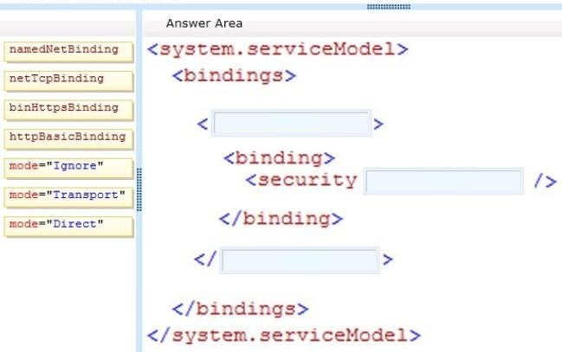

## Answer:

**QUESTION 22**

Drag and Drop Question

You are developing a WCF service. The WCF service requires implementations of the new data contracts to validate against the old schema. You need to develop a new data contract without breaking current functionality. What should you do? (To answer, drag the appropriate code segments to the correct location or locations in the answer area. Each code segment may be used once, more than once, or not at all. You may need to drag the split bar between panes or scroll to view content.)

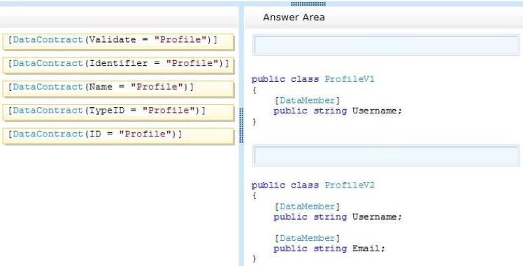

## Answer:

**QUESTION 23**

You are developing a WCF service. A new service instance must be created for each client request. You need to choose an instancing mode. Which instancing mode should you use?

|  |  |
| --- | --- |
| A. | Single |
| B. | PerRequest |
| C. | PerCall |
| D. | Multiple |
| E. | PerSession |

## Answer:

**QUESTION 24**

Drag and Drop Question

You are creating a WCF service. The service endpoints must be exposed to the Windows Azure Service Bus. The service bus has a namespace named RestaurantSB. The key provider is "owner". You need to modify the web.config file to expose the endpoints. How should you modify the file? (To answer, drag the appropriate attributes to the correct location or locations in the answer area. Each attribute may be used once, more than once, or not at all. You may need to drag the split bar between panes or scroll to view content.)

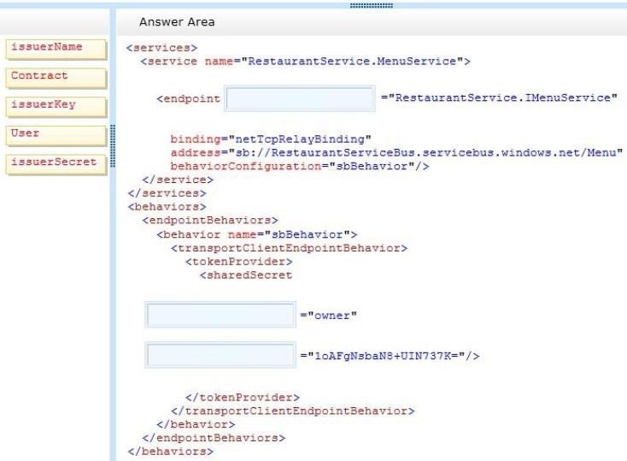

## Answer:

**QUESTION 25**

Drag and Drop Question

You are developing a WCF service. You need to implement transport security by using NTLM authentication and NetTcpBindings. Which configuration values should you use? (To answer, drag the appropriate configuration values to the correct location or locations in the answer area. Each configuration value may be used once, more than once, or not at all. You may need to drag the split bar between panes or scroll to view content.)

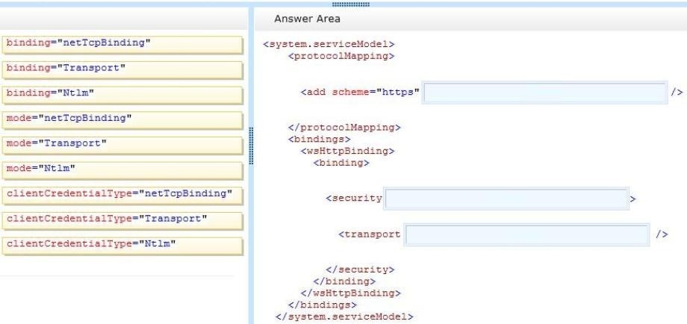

## Answer:

**QUESTION 26**

Drag and Drop Question

You are developing an ASP.NET MVC Web API application. The application must meet the following requirements:

* It must send or receive data without the use of a buffer.
* It must allow up to 1 MB of data to be received.
* It must allow up to 2 MB of data to be sent.

You need to complete the code to meet the requirements. What should you do? (To answer, drag the appropriate code segments to the correct location or locations in the answer area. Each code segment may be used once, more than once, or not at all. You may need to drag the split bar between panes or scroll to view content.)

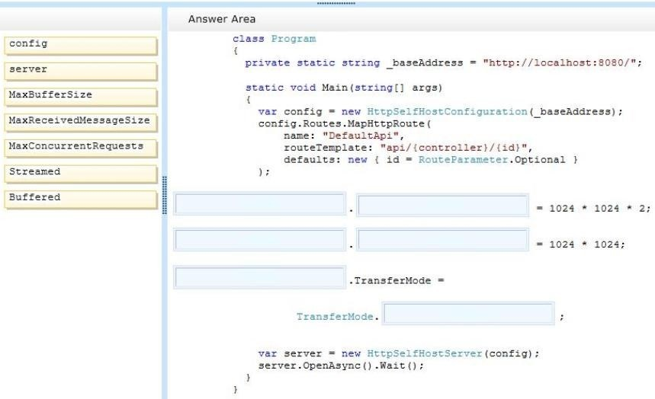

## Answer:

**QUESTION 27**

Drag and Drop Question

You are developing an ASP.NET Web API action method. The action method must return the following JSON in the message body.

{"Name": "Fabrikam", "VendorId" :9823, Items": ["Dogs", "Cats") >

You need to return an anonymous object that is serialized to JSON. What should you do? (To answer, drag the appropriate code segments to the correct location or locations in the answer area. Each code segment may be used once, more than once, or not at all. You may need to drag the split bar between panes or scroll to view content.)

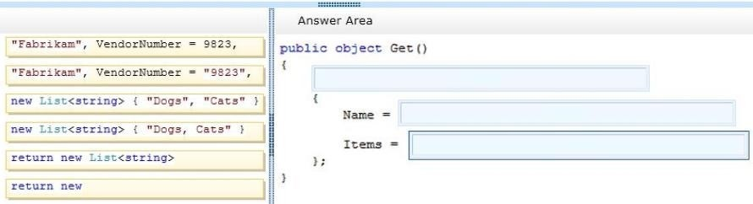

## Answer:

**QUESTION 28**

You are designing an ASP.NET Web API application. You need to select an HTTP verb to allow blog administrators to remove a comment. Which HTTP verb should you use?

|  |  |
| --- | --- |
| A. | PUT |
| B. | DELETE |
| C. | POST |
| D. | GET |

## Answer:

**QUESTION 29**

Drag and Drop Question

You are developing an ASP.NET Web API application for currency conversion that will be consumed by a web browser by using a composite application that is served from another web domain. You need to configure the Web API. What should you do? (To answer, drag the appropriate XML elements to the correct location or locations in the answer area. Each XML element may be used once, more than once, or not at all. You may need to drag the split bar between panes or scroll to view content.)

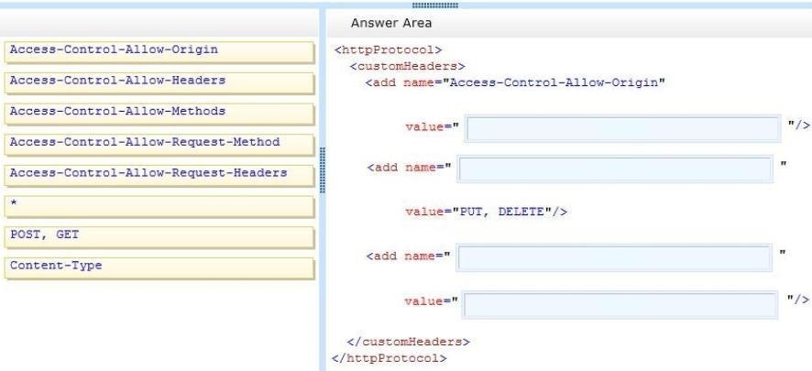

## Answer:

**QUESTION 30**

You are developing an ASP.NET MVC application. The application is an order processing system that uses the ADO.NET Entity Framework against a SQL Server database. It has a controller that loads a page that displays all orders along with customer information. Lazy loading has been disabled. The Order class is shown below.

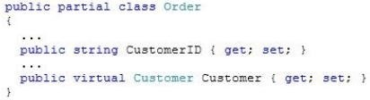

You need to return the orders and customer information in a single round trip to the database. Which code segment should you use?

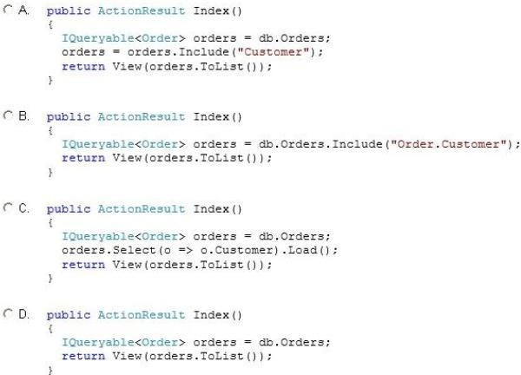

|  |  |
| --- | --- |
| A. | Option A |
| B. | Option B |
| C. | Option C |
| D. | Option D |

## Answer:

**QUESTION 31**

You are developing an ASP.NET MVC application that reads and writes data from a SQL Server database. You need to maintain data integrity in all situations that use transactions.

|  |  |
| --- | --- |
| A. | ReadUncommitted |
| B. | Repeatable |
| C. | Serializable |
| D. | ReadCommitted |

## Answer:

## QUESTION 32

Hotspot Question

You are supporting an application that uses the ADO.NET Entity Framework to query and access data. The latest version of Entity Framework contains bug fixes that will improve performance. You need to update Entity Framework. Which Visual Studio 2012 menu item should you choose? (To answer, select the appropriate menu item in the answer area.)

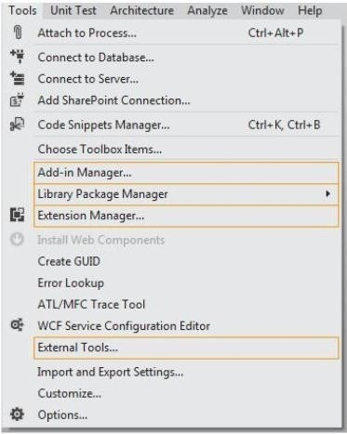

## Answer:

**QUESTION 33**

You are developing an ASP.NET MVC application. Deployment administrators do not have access to Visual Studio 2102, but will have the elevated permissions required to deploy the application to the servers. You need to select a deployment tool for use by the deployment administrators. Which tool should you use?

|  |  |
| --- | --- |
| A. | Publish Web Site Tool |
| B. | Web Deployment Package |
| C. | One-Click Publish |
| D. | Deployment Package Editor |

## Answer:

**QUESTION 34**

Drag and Drop Question

You need to configure the Windows Azure service definition to enable Consolidated Messenger to upload files. What should you do? (To answer, drag the appropriate configuration items to the correct location or locations. Each configuration item may be used once, more than once, or not at all. You may need to drag the split bar between panes or scroll to view content.)

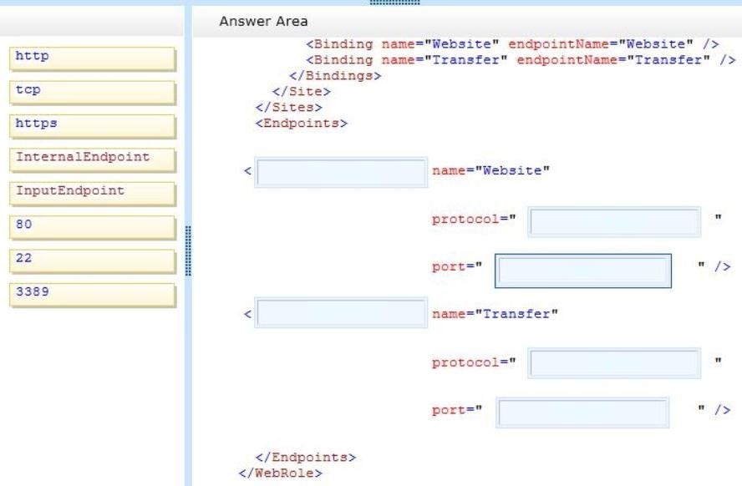

## Answer:

**QUESTION 35**

Hotspot Question

You need to deploy the application to the Windows Azure production environment to meet the

business requirements. What should you do? (To answer, select the appropriate button in the answer area.)

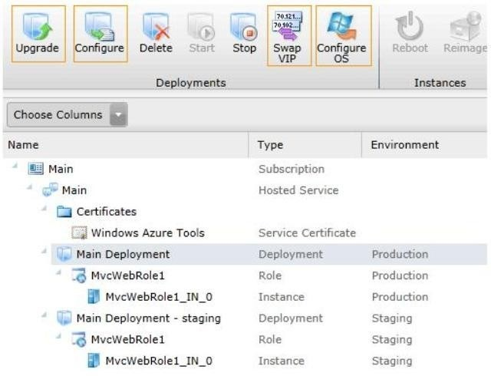

## Answer:

**QUESTION 36**

You need to recommend a data access technology to the contractor to retrieve data from the new data source. Which data access technology should you recommend?

|  |  |
| --- | --- |
| A. | LINQ to XML |
| B. | ADO.NET Entity Framework |
| C. | ADO.NET DataSets |
| D. | WCF Data Services |

## Answer:

**QUESTION 37**

Drag and Drop Question

Flight information data provided by Margie's Travel is updated both locally and remotely. When the data is synced, all changes need to be merged together without causing any data loss or corruption. You need to implement the Sync() method in the MargiesTravelSync.es file. What should you do? (To answer, drag the appropriate code segments to the correct location or locations in the answer area. Each code segment may be used once, more than once, or not at all. You may need to drag the split bar between panes or scroll to view content.)

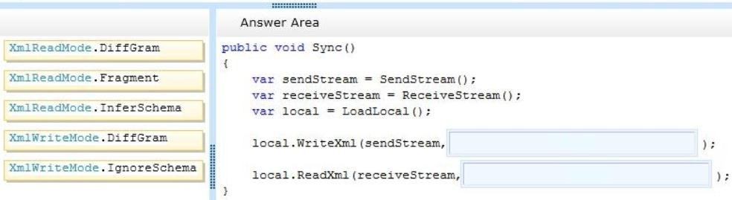

## Answer:

**QUESTION 38**

Drag and Drop Question

Historical flight information data will be stored in Windows Azure Table Storage using the FlightInfo class as the table entity. There are millions of entries in the table. Queries for historical flight information specify a set of airlines to search and whether the query should return only late flights. Results should be ordered by flight name. You need to specify which properties of the FlightInfo class should be used at the partition and row keys to ensure that query results are returned as quickly as possible. What should you do? (To answer, drag the appropriate properties to the correct location or locations in the answer area. Each property may be used once, more than once, or not at all. You may need to drag the split bar between panes or scroll to view content.)

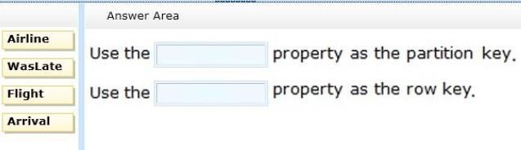

## Answer:

**QUESTION 39**

Drag and Drop Question

The service has been deployed to Windows Azure. Trey Research has provided version 1.3.0.0 of the assembly to support a change in the serialization format. The service must remain available during the transition to the new serialization format. You need to ensure that the service is using the new assembly. Which configuration setting should you add to the web.config? (To answer, drag the appropriate configuration elements to the correct location or locations in the answer area. Each configuration element may be used once, more than once, or not at all. You may need to drag the split bar between panes or scroll to view content.)

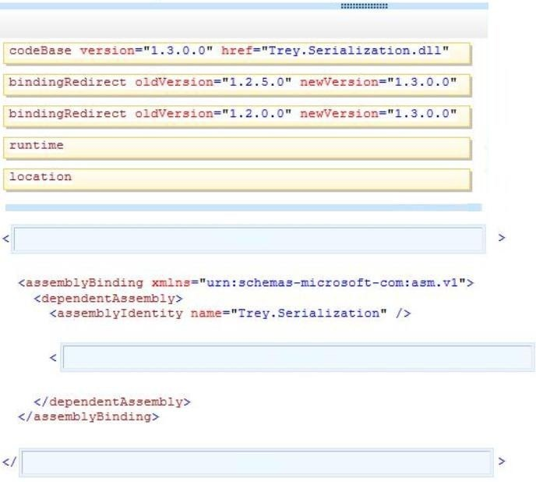

## Answer:

**QUESTION 40**

Errors occasionally occur when saving data using the FlightInfoContext ADO.NET Entity Framework context. Updates to the data are being lost when an error occurs. You need to ensure that data is still saved when an error occurs by retrying the operation. No more than five retries should be performed. Which code segment should you use as the body of the SaveChanges() method in the FlightInfoContext.es file?

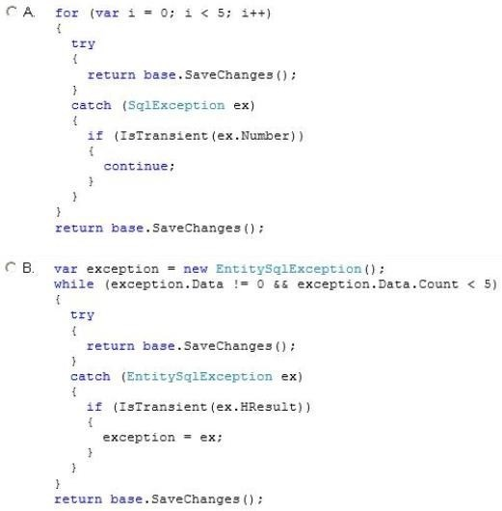

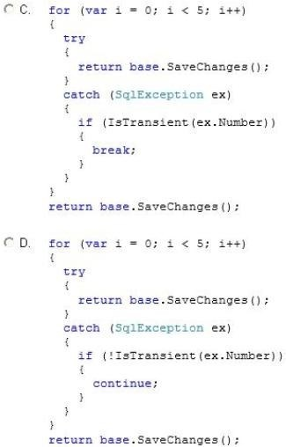

|  |  |
| --- | --- |
| A. | Option A |
| B. | Option B |
| C. | Option C |
| D. | Option D |

## Answer:

## QUESTION 41

You are adding a new REST service endpoint to the FlightDataController controller. It returns flights from the consolidated data sources only for flights that are late. You need to write a LINQ to Entities query to extract the required data. Which code segment should you use?

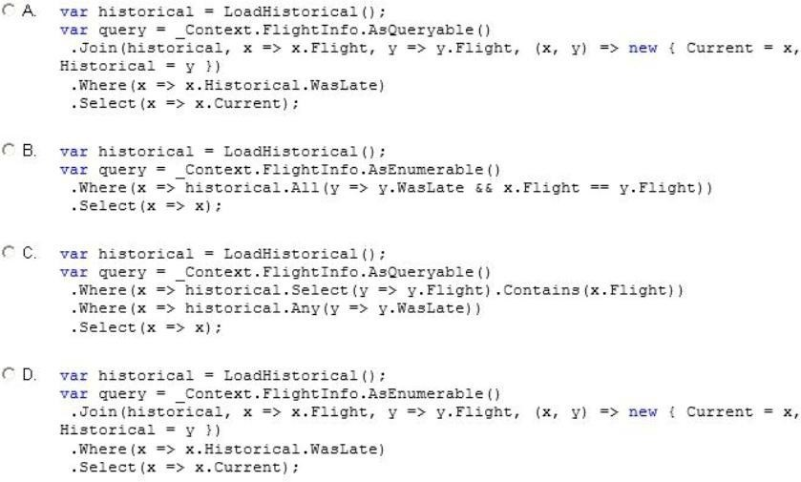

|  |  |
| --- | --- |
| A. | Option A |
| B. | Option B |
| C. | Option C |
| D. | Option D |

## Answer:

## QUESTION 42

Data provided by Consolidated Messenger is cached in the HttpContext.Cache object. You need to ensure that the cache is correctly updated when new data arrives. What should you do?

|  |  |
| --- | --- |
| A. | Ensure that the EffectivePrivateBytesLimit value is greater than the size of the database file. |
| B. | Change the sliding expiration of the cache item to 12 hours. |
| C. | Use the SqlCacheDependency type configured with a connection string to the database file. |
| D. | Use the CacheDependency type configured to monitor the SFTP target folder. |

## Answer:

**QUESTION 43**

You need to load flight information provided by Consolidated Messenger. Which should you use?

|  |  |
| --- | --- |
| A. | SQL Server Data Transformation Services (DTS) |
| B. | EntityTransaction and EntityCommand |
| C. | Office Open XML |
| D. | OleDbConnection and OleDbDataReader |

## Answer:

**QUESTION 44**

Drag and Drop Question

You need to parse flight information from Blue Yonder Airlines. The content of the XML file is shown below.

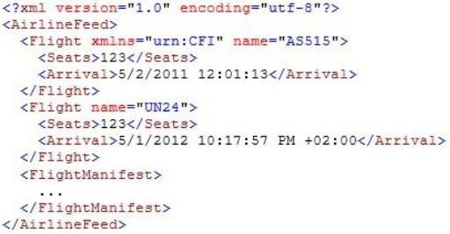

Some airlines do not specify the timezone of the arrival time. If the timezone is not specified, then it should be interpreted per the business requirements. You need to implement the LoadFlights() and Parse() methods of the BlueYonderLoader class. What should you do? (To answer, drag the appropriate code segments to the correct location in the answer area. Each segment may be used once, more than once, or not at all. You may need to drag the split bar between panes or scroll to view content.)

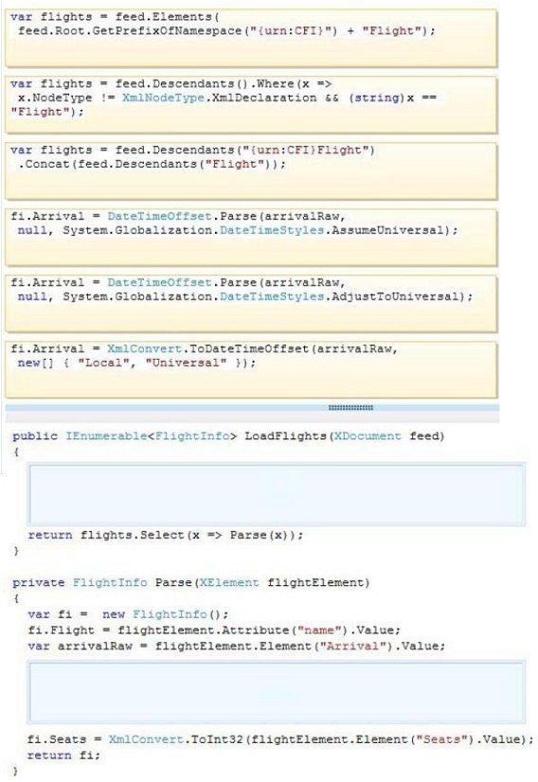

## Answer:

**QUESTION 45**

You are adding a new REST service endpoint to the FlightDataController controller that returns the total number of seats for each airline. You need to write a LINQ to Entities query to extract the required data. Which code segment should you use?

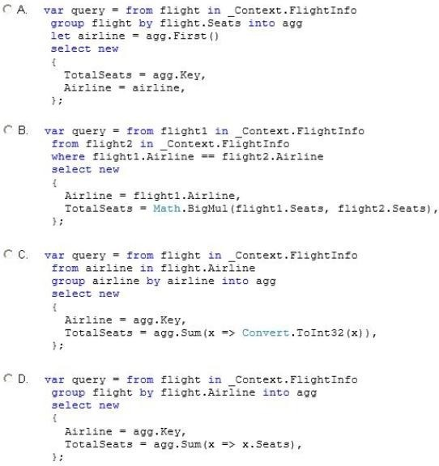

|  |  |
| --- | --- |
| A. | Option A |
| B. | Option B |
| C. | Option C |
| D. | Option D |

## Answer:

**QUESTION 46**

Historical flight information data will be stored in Windows Azure Table Storage using the FlightInfo class as the table entity. There are millions of entries in the table. Queries for historical flight information specify a set of airlines to search and whether the query should return only late flights. Results should be ordered by flight name. You need to specify which properties of the FlightInfo class should be used at the partition and row keys to ensure that query results are returned as quickly as possible. What should you do? (Each correct answer presents part of the solution. Choose all that apply.)

|  |  |
| --- | --- |
| A. | Use the WasLate property as the row key. |
| B. | Use the Airline property as the row key. |
| C. | Use the WasLate property as the partition key. |
| D. | Use the Arrival property as the row key. |
| E. | Use the Airline property as the partition key. |
| F. | Use the Flight property as the row key. |

## Answer:

**QUESTION 47**

Transformed historical flight information provided by the RemoteDataStream() method must be written to the response stream as a series of XML elements named Flight within a root element named Flights. Each Flight element has a child element named FlightName that contains the flight name that starts with the two-letter airline prefix. You need to implement the StreamHistoricalFlights() method so that it minimizes the amount of memory allocated. Which code segment should you use as the body of the StreamHistoricalFlights() method in the HistoricalDataLoader.es file?

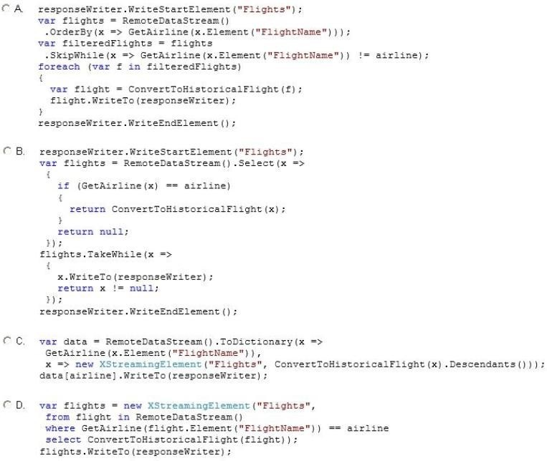

|  |  |
| --- | --- |
| A. | Option A |
| B. | Option B |
| C. | Option C |

|  |  |
| --- | --- |
| D. | Option D |

## Answer:

## QUESTION 48

Errors occasionally occur when saving data using the FlightlnfoContext ADO.NET Entity Framework context. Updates to the data are being lost when an error occurs. You need to ensure that data is still saved when an error occurs by retrying the operation. No more than five retries should be performed. With which code segment should you replace the body of the SaveChanges() method in the FlightInfoContext.es file?

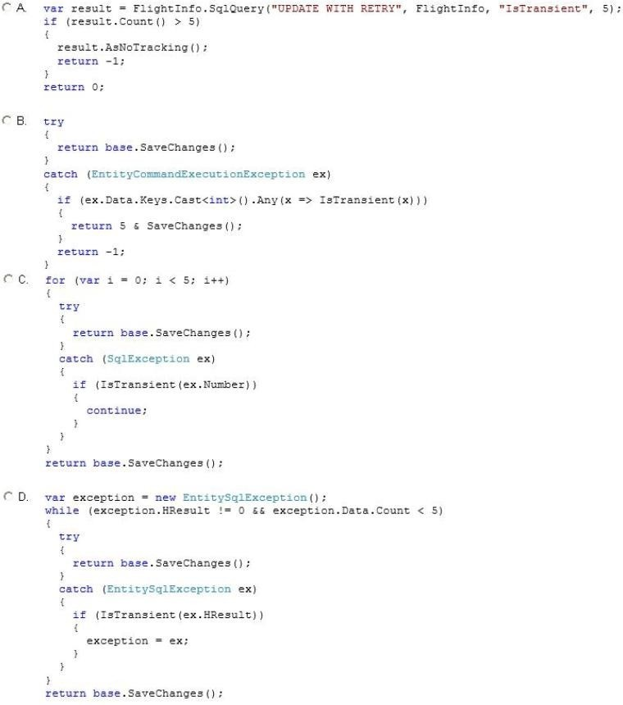

|  |  |
| --- | --- |
| A. | Option A |
| B. | Option B |
| C. | Option C |
| D. | Option D |

## Answer:

**QUESTION 49**

The QueueDetail entity type must inherit from the InboundQueue entity type in the ExternalQueue service project using table-per-type inheritance. You need to modify the entities in the designer. What should you do? (Each correct answer presents part of the solution. Choose all that apply.)

|  |  |
| --- | --- |
| A. | Remove the OrderNum property in InboundQueue. |
| B. | Remove the OrderNum property in QueueDetail. |
| C. | Set the QueueDetail BaseType to InboundQueue. |
| D. | Remove the association between the entities. |
| E. | Right-click the entities and validate the table mapping. |
| F. | Set the InboundQueue BaseType to QueueDetail. |

**Answer:**

## QUESTION 50

Drag and Drop Question

The GetVendorPolicy() private method in the ProcessedOrderController controller is returning a CacheItemPolicy object with default values. The returned policy must expire if the external file located at C:\Triggers\VendorTrigger.txt has been modified or the timeout outlined in the technical requirements is reached. You need to return the policy. How should you build the method? (To answer, drag the appropriate code segments to the correct location or locations in the answer area. Each code segment may be used once, more than once, or not at all. You may need to drag the split bar between panes or scroll to view content.)

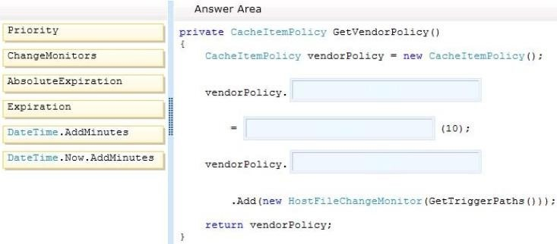

## Answer:

**QUESTION 51**

The GetExternalOrder() method in the ExternalQueueService service is throwing a runtime error. The method must query the database for a record that matches the orderNum parameter passed to the method. You need to modify the queryString string to retrieve the record. With which code segment should you replace line EQ64?

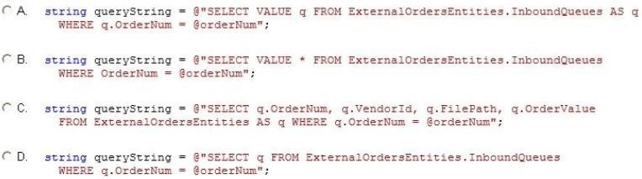

|  |  |
| --- | --- |
| A. | Option A |
| B. | Option B |

|  |  |
| --- | --- |
| C. | Option C |
| D. | Option D |

## Answer:

## QUESTION 52

Drag and Drop Question

You add a class named ShippingInfo. You need to modify the IShippingService interface and the ShippingInfo class to meet the technical requirements. What should you do? (To answer, drag the appropriate code segments to the correct location or locations in the answer area. Each code segment may be used once, more than once, or not at all. You may need to drag the split bar between panes or scroll to view content.)

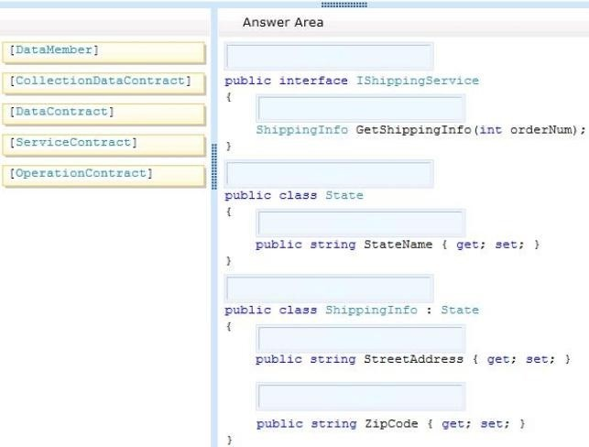

## Answer:

**QUESTION 53**

Drag and Drop Question

You need to create the ShippingContext class in the ShippingAddress.es file to meet the requirements. What should you do? (To answer, drag the appropriate code segments to the correct location or locations in the answer area. Each code segment may be used once, more than once, or not at all. You may need to drag the split bar between panes or scroll to view content.)

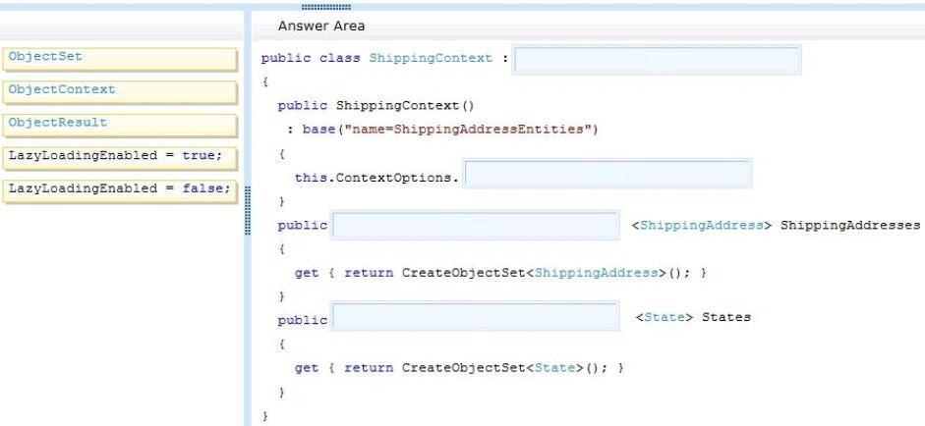

## Answer:

**QUESTION 54**

You need to modify the ExecuteCommandProcedure() method to meet the technical requirements. Which code segment should you use?

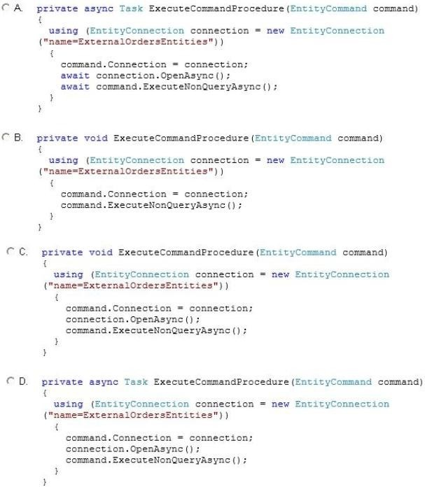

|  |  |
| --- | --- |
| A. | Option A |
| B. | Option B |
| C. | Option C |
| D. | Option D |

## Answer:

**QUESTION 55**

Drag and Drop Question

You need to complete the GetProcessedOrders() action in the ProcessedOrderController controller to meet the requirements. What should you do? (To answer, drag the appropriate code segments to the correct location or locations in the answer area. Each code segment may be used once, more than once, or not at all. You may need to drag the split bar between panes or scroll to view content.)

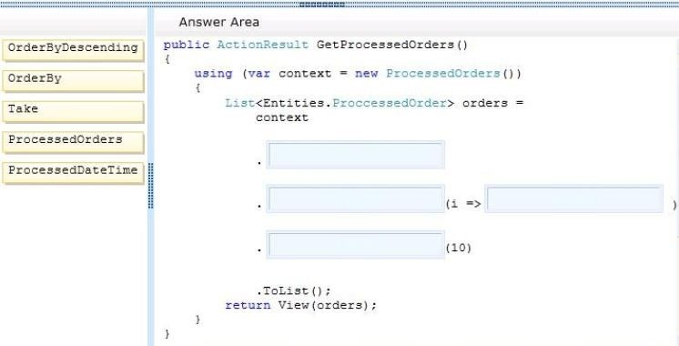

## Answer:

**QUESTION 56**

Drag and Drop Question

The GetQueueItems() action in the InboundQueueController controller is not populating the view with data. The action must populate the view with data by calling the GetExternalOrders() method in the ExternalQueueService service using the ChannelFactory class. You need to modify the action to populate the view with data. What should you do? (To answer, drag the appropriate code segments to the correct location or locations in the answer area. Each code segment may be used once, more than once, or not at all. You may need to drag the split bar between panes or scroll to view content.)

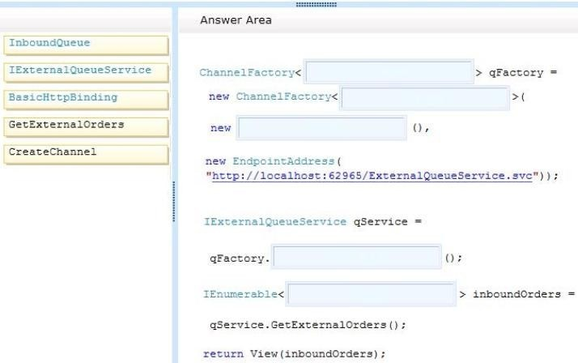

## Answer:

**QUESTION 57**

The DeleteExternalOrder() method in the ExternalQueueService service is not throwing a FaultException exception as defined by the FaultContractAttribute attribute in the IExternalQueueService.cs file. You need to throw the FaultException exception. Which code segments can you insert at line EQ45 to achieve this goal? (Each correct answer presents a complete solution. Chose all that apply)

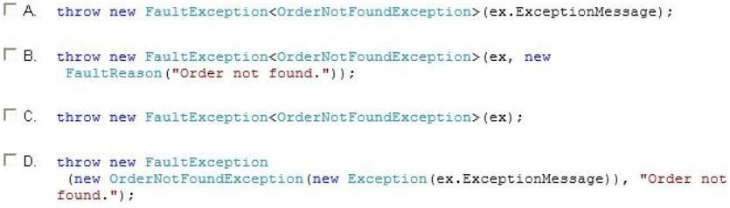

|  |  |
| --- | --- |
| A. | Option A |
| B. | Option B |
| C. | Option C |
| D. | Option D |

## Answer:

**QUESTION 58**

Drag and Drop Question

The GetExternalOrders() method must use members of the EntityClient namespace to query the database for all records in the InboundQueue entity. You need to modify the GetExternalOrders() method to return the correct data. What should you do? (To answer, drag the appropriate code segments to the correct location or locations in the answer area. Each code segment may be used once, more than once, or not at all. You may need to drag the split bar between panes or scroll to view content.)

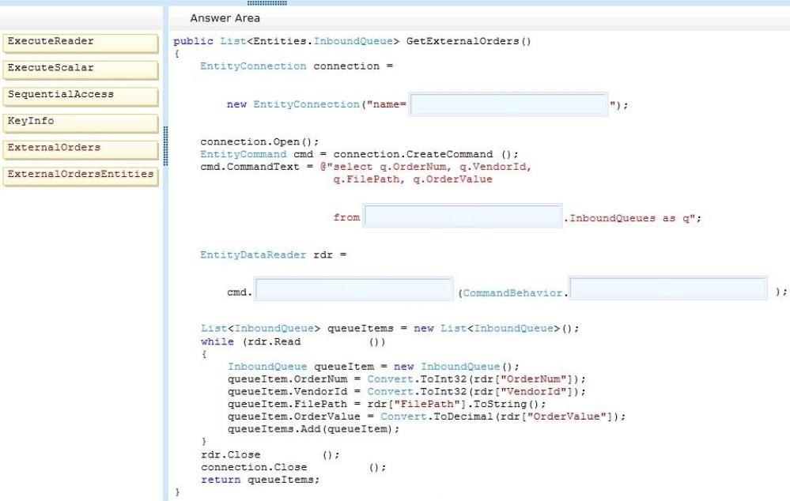

## Answer:

**QUESTION 59**

You need to regenerate the service proxies to include task-based asynchronous method signatures. Which command should you use?

|  |  |
| --- | --- |
| A. | aspnet_regiis.exe /t:code http://localhost:62965/UploadCallbackService.svc |
| B. | svcutil.exe /t:code http://localhost:62965/UploadCallbackService.svc |
| C. | aspnet_compiler.exe /t:code http://localhost:62965/UploadCallbackService.svc |
| D. | aspnet_regiis.exe /t:code http://localhost:62965/UploadService.svc |
| E. | svcutil.exe /t:code http://localhost:62965/UploadService.svc |

## Answer:

## QUESTION 60

The DeleteExternalOrder() method in the ExternalQueueService service is not throwing a FaultException exception as defined by the FaultContractAttribute attribute in the IExternatQueueService.cs file. You need to throw the FaultException exception. Which code segment can you insert at line EQ45 to achieve this goal? (Each correct answer presents a complete solution. Chose all that apply.)

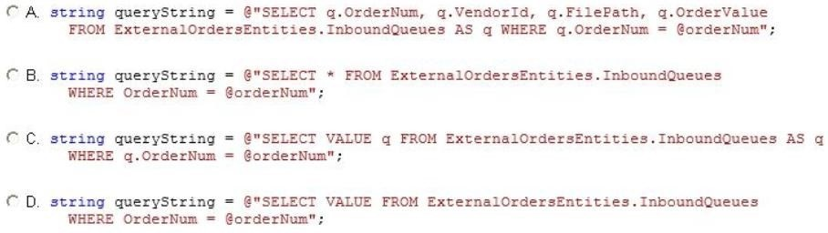

|  |  |
| --- | --- |
| A. | Option A |
| B. | Option B |
| C. | Option C |
| D. | Option D |

## Answer:

## QUESTION 61

Drag and Drop Question

You need to modify the ExecuteCommandProcedure() method to meet the technical requirements. Which code segment should you use?

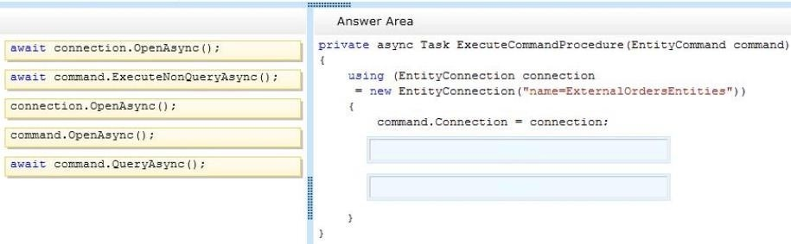

## Answer:

**QUESTION 62**

The GetVendors() action in the ProcessedOrderController controller is querying the database each time it is run. The GetVendors() action must query the database only if the cache is null. You need to add code to the action at line PC33 to cache the data. Which code segment can you use? (Each correct answer presents a complete solution. Choose all that apply.)

|  |  |
| --- | --- |
| A. | cache.Set(new CacheItem("vendorKey", vendors), GetVendorPolicy()); |
| B. | cache.Add("vendors", vendors, new CacheItemPolicy()); |
| C. | cache.Add(new CacheItem("vendorKey", vendors) , GetVendorPolicy()); |
| D. | cache.AddOrGetExisting("vendorKey", context, new CacheItemPolicy()); |

## Answer:

**QUESTION 63**

Drag and Drop Question

The UploadOrder() method in the UploadCallbackService service is not implementing the callback behavior defined in the IUploadCallBackService interface. You need to modify the class to implement the required callback behavior. What should you do? (To answer, drag the appropriate code segments to the correct location or locations in the answer area. Each code segments may be used once, more than once, or not at all. You may need to drag the split bar between panes or scroll to view content.)

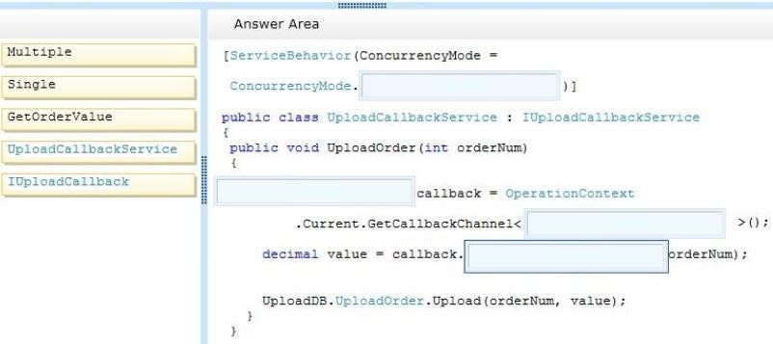

## Answer:

**QUESTION 64**

You need to choose the appropriate data access technology for the children's book area of the web application. Which data access technology should you choose?

|  |  |
| --- | --- |
| A. | Web Service |
| B. | LINQ to SQL |
| C. | ADO.NET Entity Framework |
| D. | WCF Data Services |

## Answer:

**QUESTION 65**

You need to update the CreateMonthlyTotalsReports() method to use database transactions. Which code segment should you use?

|  |  |
| --- | --- |
| A. | SqlConnection.BeginTransaction(IsolationLevel.ReadCommitted); |
| B. | SqlConnection.BeginTransaction(IsolationLevel.ReadUnconwited); |
| C. | SqlConnection.BeginTransaction(IsolationLevel.Chaos); |
| D. | SqlConnection.BeginTransaction(IsolationLevel.Serializable); |

## Answer:

## QUESTION 66

The PurchaseOrders.xml file contains all of the purchase orders for the day. You need to query the XML file for all of the shipping addresses. Which code segment should you use?

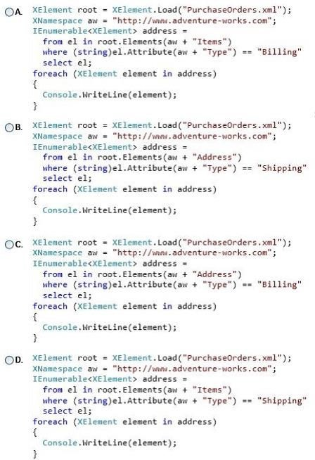

|  |  |
| --- | --- |
| A. | Option A |
| B. | Option B |
| C. | Option C |
| D. | Option D |

## Answer:

**QUESTION 67**

Drag and Drop Question

An XML file must be produced by the SaveFeaturedBooks() method of the Book class. The schema of the resulting XML file must be identical to the FeaturedBooks.xml file. You need to write the code to produce the file. You have the following code:

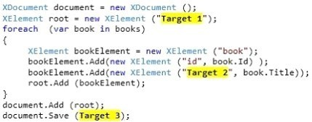

Which code segments should you include in Target 1, Target 2 and Target 3 to complete the code? (To answer, drag the appropriate code segments to the correct targets in the answer area. Each code segment may be used once, more than once, or not at all. You may need to drag the split bar between panes or scroll to view content)

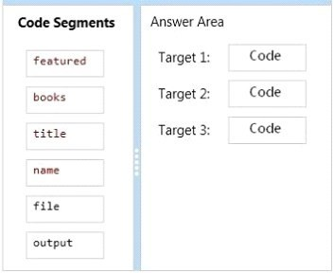

## Answer:

**QUESTION 68**

You need to choose the appropriate data access strategy for the college textbook area of the web

application. Which data access technology should you implement?

|  |  |
| --- | --- |
| A. | ADO.NET |
| B. | Entity Data Model (EDM) |
| C. | WCF Data Services |
| D. | LINQ to SQL |

## Answer:

## QUESTION 69

You need to configure the server to self-host the bookstore's Web API application. Which code segment should you use?

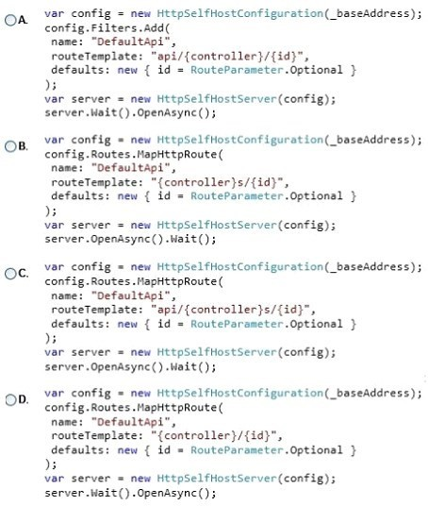

|  |  |
| --- | --- |
| A. | Option A |
| B. | Option B |
| C. | Option C |
| D. | Option D |

## Answer:

## QUESTION 70

You need to return the list of the top 100 books for the GetTopBooks() method. Which type should you use to retrieve the data?

|  |  |
| --- | --- |
| A. | SqlDataReader |
| B. | DataSet |
| C. | DataTable |
| D. | Data View |

## Answer:

**QUESTION 71**

You need to choose the appropriate data access technology for the cookbook area of the web application. Which data access technology should you choose?

|  |  |
| --- | --- |
| A. | WCF Data Services |
| B. | LINQ to SQL |
| C. | Entity Framework |
| D. | ADO.NET |

## Answer:

## QUESTION 72

You are preparing to write the data access code for the children's book area of the web site. You need to review the requirements and identify the appropriate data access technology. What should you do?

|  |  |
| --- | --- |
| A. | Use ADO.NET Entity Framework. |
| B. | Use a Web Service. |
| C. | Use the WCF Data Services. |
| D. | Use LINQ to SQL. |

## Answer:

**QUESTION 73**

The PurchaseOrders.xml file contains all of the purchase orders for the day. You need to query the XML file for all of the billing addresses. Which code segment should you use?

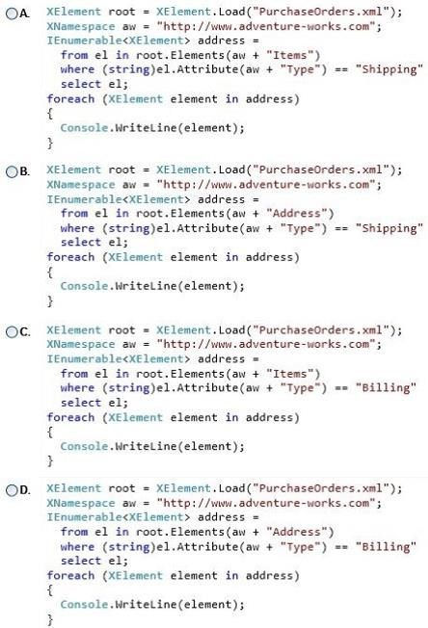

|  |  |
| --- | --- |
| A. | Option A |
| B. | Option B |
| C. | Option C |
| D. | Option D |

## Answer:

**QUESTION 74**

You need to create an OData filter expression that returns books that match the following characteristics:

* Published after 1/1/2000

* Have "Science" as the first word

Which filter statement should you use?

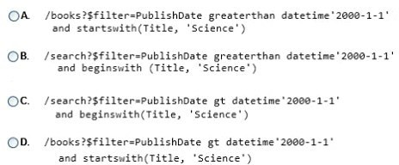

|  |  |
| --- | --- |
| A. | Option A |
| B. | Option B |
| C. | Option C |
| D. | Option D |

## Answer:

## QUESTION 75

You need to update the ImportBooks() method to use database transactions. Which code segment should you use?

|  |  |
| --- | --- |
| A. | SqlConnection.BeginTransaction(IsolationLevel.RepeatableRead); |
| B. | SqlConnection.BeginTransaction(IsolationLeve.ReadUnconvnited); |
| C. | SqlConneetion.BeginTransaction(IsolationLevel.Serializable); |
| D. | SqlConnection.BeginTransaction(IsolationLevel.Snapshot); |

## Answer:

## QUESTION 76

You need to implement the Get() method in the bookstore Web API application to be able to find books by using an ad hoc query. Which method should you use?

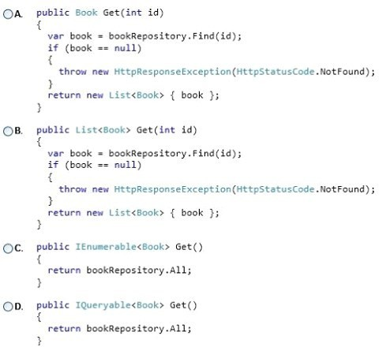

|  |  |
| --- | --- |
| A. | Option A |
| B. | Option B |
| C. | Option C |
| D. | Option D |

## Answer:

**QUESTION 77**

Drag and Drop Question

You need to update the GetBook() method to retrieve book data by using ADO.NET. You have the following code:

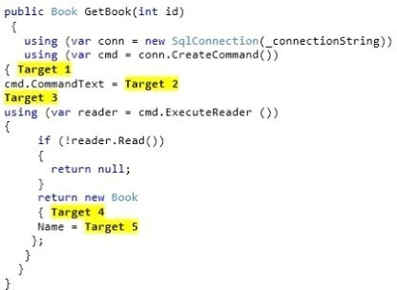

Which code segments should you include in Target 1, Target 2, Target 3, Target 4 and Target 5 to complete the code? (To answer, drag the appropriate code segments to the correct targets in the answer area. Each code segment may be used once, more than once, or not at all. You may need to drag the split bar between panes or scroll to view content.)

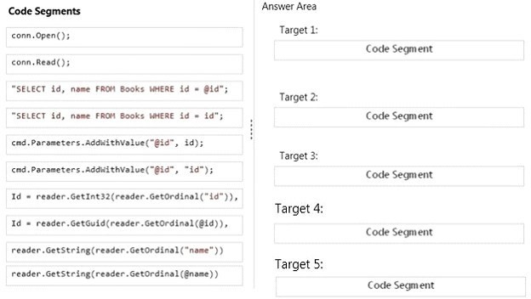

## Answer:

**QUESTION 78**

You need to create an OData query expression to return the ten books with the largest number of sales. Which query expression should you use?

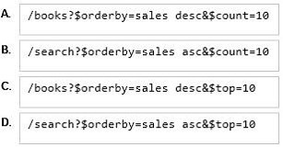

|  |  |
| --- | --- |
| A. | Option A |
| B. | Option B |
| C. | Option C |
| D. | Option D |

## Answer:

## QUESTION 79

Drag and Drop Question

You are developing an ASP.NET MVC Web API application. The methods of the Web API must return details about the result of the operation. You need to create methods to update and delete products. You have the following code:

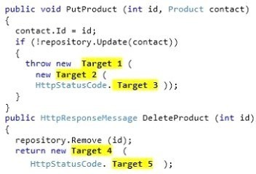

Which code segments should you include in Target 1, Target 2, Target 3, Target 4 and Target 5 to complete the code? (To answer, drag the appropriate code segments to the correct targets in the answer area. Each code segment may be used once, more than once, or not at all. You may need to drag the split bar between panes or scroll to view content.)

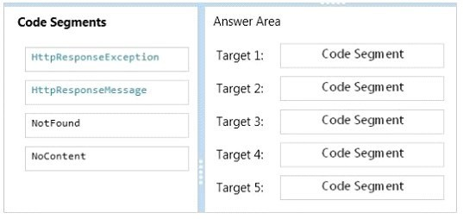

## Answer:

**QUESTION 80**

Hotspot Question

You are developing an application. The application must be deployed from Team Foundation Server after a successful build is completed. The Process tab of the Build Definition screen is shown in the exhibit.

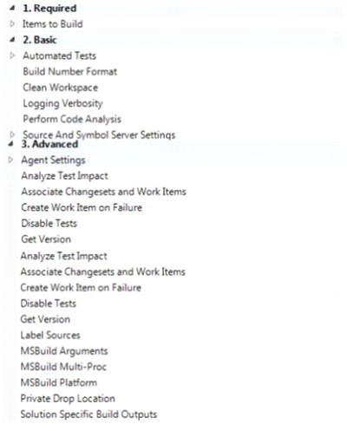

You need to configure the automated deployment. In which section should you define the parameters for the automated deployment? (To answer, select the appropriate section in the answer area.)

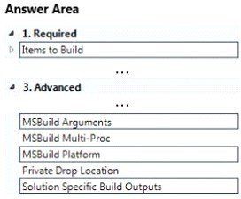

## Answer:

## QUESTION 81

Drag and Drop Question

You are developing an ASP.NET Web API for a home inventory management system. You need to limit access to users with IP addresses based only in the United States. You have the following code:

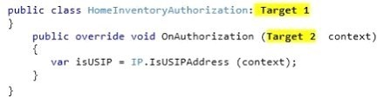

Which code segments should you include in Target 1 and Target 2 to complete the code? (To answer, drag the appropriate code segments to the correct targets in the answer area. Each code segment may be used once, more than once, or not at all. You may need to drag the split bar between panes or scroll to view content.)

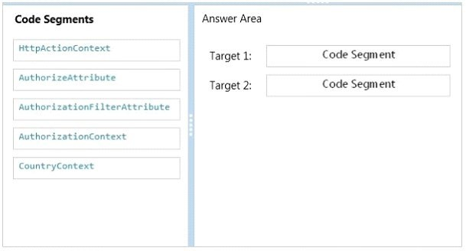

## Answer:

**QUESTION 82**

Drag and Drop Question

You are developing an Internet-based ASP.NET Web API application that manages pet data. You install an SSL certificate on the web server to encrypt calls to the API. You create a class named PetAuthorization, which inherits from a type named AuthorizeAttribute, and implements the OnAuthorization() method. You need to implement basic authentication for the API. What should you do? (To answer, drag the appropriate words to the correct targets in the answer area. Words may be used once, more than once, or not at all. You may need to drag the split bar between panes or scroll to view content)

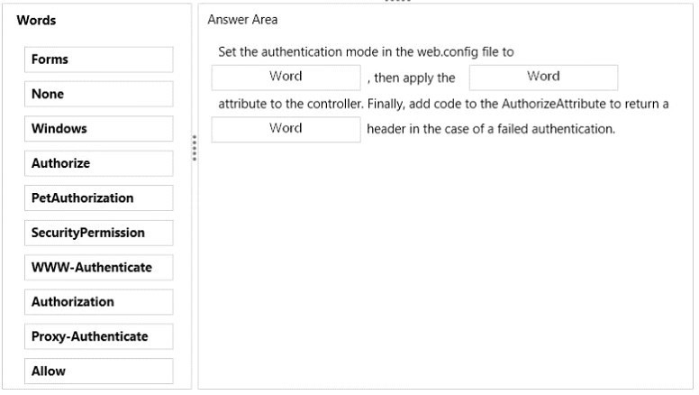

## Answer:

**QUESTION 83**

You are developing an ASP.NET MVC application. The application is an order processing system that uses the ADO.NET Entity Framework against a SQL Server database. It has a controller that loads a page that displays customers. Customers are filtered on Country and, if provided, on CompanyName. You have an Entity Framework context named db. The Customer class is shown below.

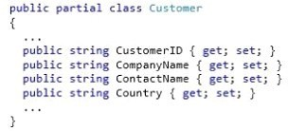

You need to execute a single deferred query to return the filtered list of customers. Which code segment should you use?

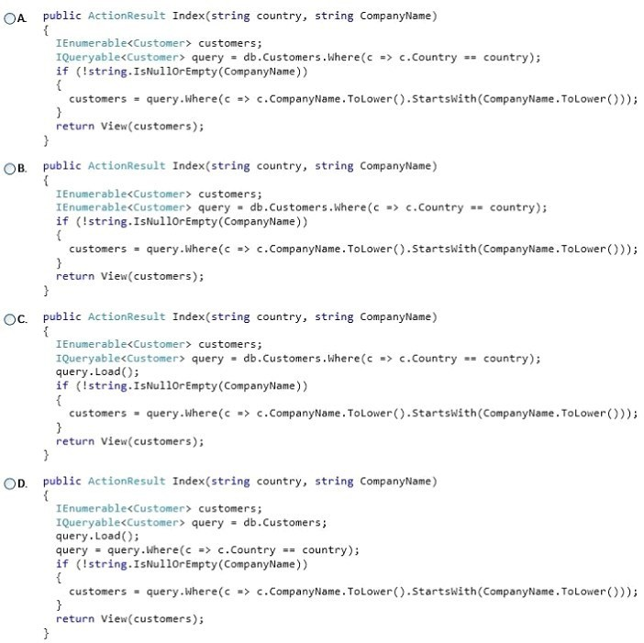

|  |  |
| --- | --- |
| A. | Option A |
| B. | Option B |
| C. | Option C |
| D. | Option D |

## Answer:

**QUESTION 84**

Drag and Drop Question

You are developing a self-hosted WCF service to display data about books. The solution contains a service named BookService that implements the IBookService interface. You need to expose the metadata in the service host programmatically. You have the following code:

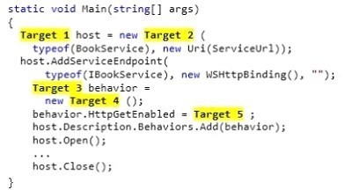

Which code segments should you include in Target 1, Target 2, Target 3, Target 4 and Target 5 to build the service host? (To answer, drag the appropriate code segments to the correct targets in the answer area. Each code segment may be used once, more than once, or not at all. You may need to drag the split bar between panes or scroll to view content.)

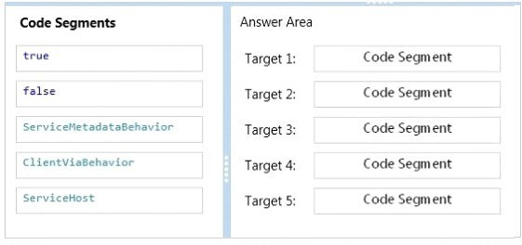

## Answer:

**QUESTION 85**

You are developing an ASP.NET MVC application. The application is a loan processing system that uses the ADO.NET Entity Framework against a SQL Server database. It has a controller that loads a page that displays all loans along with rate information. Lazy loading has been disabled. The Loan class is shown below.

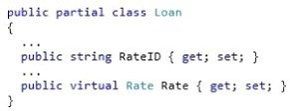

You need to return the loans and rate information in a single round trip to the database. Which code segment should you use?

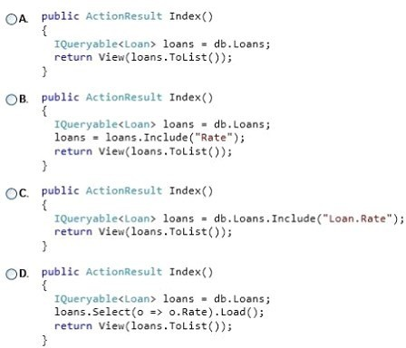

|  |  |
| --- | --- |
| A. | Option A |
| B. | Option B |
| C. | Option C |
| D. | Option D |

## Answer:

**QUESTION 86**

You are developing a library management application that uses the ADO.NET Entity Framework against a SQL Server database. The application has a method that returns check outs filtered by date. The Book class is shown below.

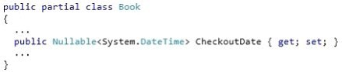

You must filter the data on the SQL server before it is returned to the application server. You need to return books checked out more recently than the entered date. Which code segment should you use?

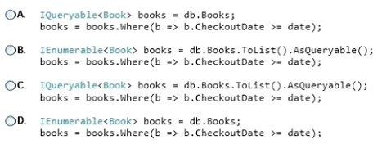

|  |  |
| --- | --- |
| A. | Option A |
| B. | Option B |
| C. | Option C |
| D. | Option D |

## Answer:

## QUESTION 87

Hotspot Question

You are developing an ASP.NET MVC application. It is ready for deployment to the production web server. A local SQL Express .MDF file was used by the application during development. The deployment has the following requirements:

* The deployment must merge the assemblies on the local machine with those on the host.
* The deployment must publish the local database to the remote Microsoft SQL server.

You need to configure the web package settings for deployment. Which settings should you use? (To answer, select the appropriate setting or settings in the answer area.)

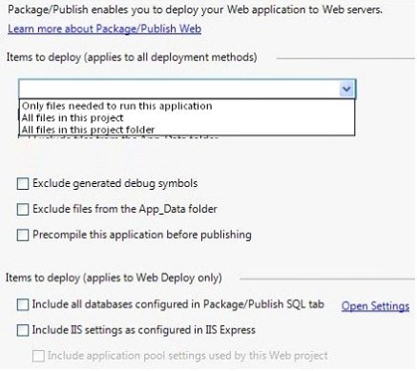

## Answer:

**QUESTION 88**

You are developing a Microsoft Azure web application. The application will be deployed to 10 web role instances. A minimum of 8 running instances is needed to meet scaling requirements. You need to configure the application so that upgrades are performed as quickly as possible, but do not violate scaling requirements. How many upgrade domains should you use?

|  |  |
| --- | --- |
| A. | 1 |
| B. | 2 |
| C. | 5 |
| D. | 10 |

## Answer:

**QUESTION 89**

Hotspot Question

You are supporting an application that uses the ADO.NET Entity Framework to query and access data. The latest version of a tool will add new templates and wizards that will enhance developer productivity. You need to update the tool. Which Visual Studio 2012 menu item should you choose? (To answer, select the appropriate menu item in the answer area.)

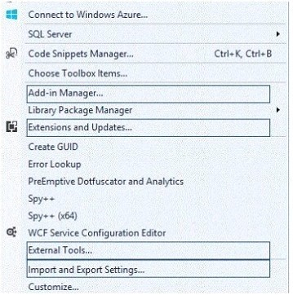

## Answer:

**QUESTION 90**

You are developing an ASP.NET MVC application that displays a report. The report includes large images that are stored in a database. Members of the EntityClient namespace are used to access the database through the ADO.NET Entity Framework data model. You need to prevent memory exceptions while generating a report using the EntityDataRcader type. Which CommandBehavior type should you use?

|  |  |
| --- | --- |
| A. | FastForwardReadOnly |
| B. | SequentialAccess |
| C. | SingleResult |
| D. | SingleRow |

## Answer:

## QUESTION 91

You are developing an ASP.NET MVC application. The application has a page that searches for and displays an image stored in a database. Members of the EntityClient namespace are used to access an ADO.NET Entity Framework data model. Images and associated metadata are stored in a database table. You need to run a query that returns only the image while minimizing the amount of data that is transmitted. Which method of the EntityCommand type should you use?

|  |  |
| --- | --- |
| A. | ExecuteScalar |
| B. | ExecuteDbDataReader |
| C. | ExecuteReader |
| D. | ExecuteNonQuery |

## Answer:

## QUESTION 92

You are developing an order processing application that uses the ADO.NET Entity Framework against a SQL Server database. Lazy loading has been disabled. The application displays orders and their associated order details. Order details are filtered based on the category of the product in each order. The Order class is shown below.

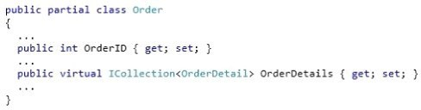

The OrderDetail class is shown below.

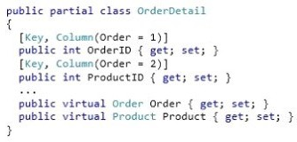

The Product class is shown below.

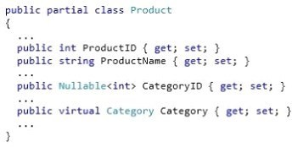

The Category class is shown below.

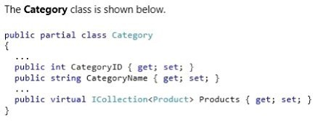

You need to return orders with their filtered list of order details included in a single round trip to the database. Which code segment should you use?

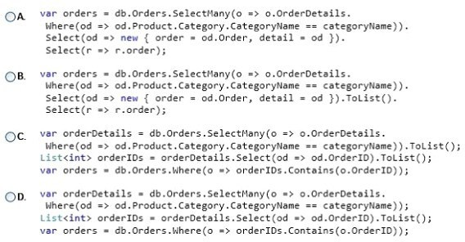

|  |  |
| --- | --- |
| A. | Option A |
| B. | Option B |
| C. | Option C |
| D. | Option D |

## Answer:

**QUESTION 93**

Drag and Drop Question

You are developing a WCF service application. The application must meet the following requirements:

* Operations must have 30 second timeouts.
* The service must have a transaction scope.
* Transactions must flow from the client to the server.

You need to write a transactional service contract and implementation class to meet the requirements. You have the following code:

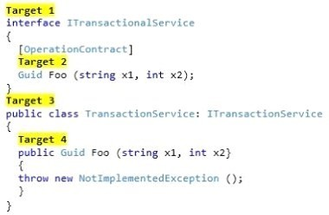

Which code segments should you include in Target 1, Target 2, Target 3 and Target 4 to complete the code? (To answer, drag the appropriate code segments to the correct targets in the answer area. Each code segment may be used once, more than once, or not at all. You may need to drag the split bar between panes or scroll to view content.)

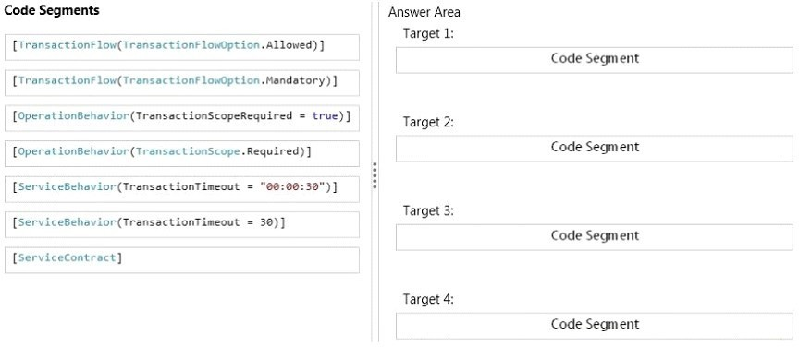

## Answer:

**QUESTION 94**

Drag and Drop Question

You are developing a WCF service. You need to configure the web.config file to ensure that metadata is exposed only via the MEX protocol. You have the following markup:

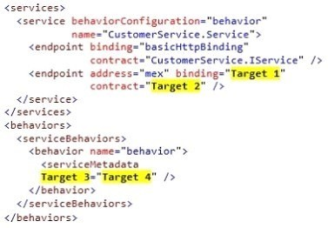

Which XML elements should you include in Target 1, Target 2, Target 3 and Target 4 to complete the markup? (To answer, drag the appropriate XML elements to the correct targets in the answer area. Each XML element may be used once, more than once, or not at all. You may need to drag the split bar between panes or scroll to view content.)

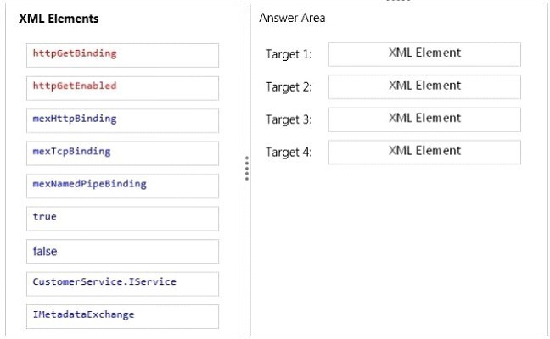

## Answer:

**QUESTION 95**

Hotspot Question

You are developing a WCF service in Visual Studio 2013 that integrates with the Microsoft Azure service bus relay. The Azure service bus namespace is named RestaurantServiceBus. You need to obtain the issuer name and secret. What should you do? (To answer, select the appropriate option in the answer area.)

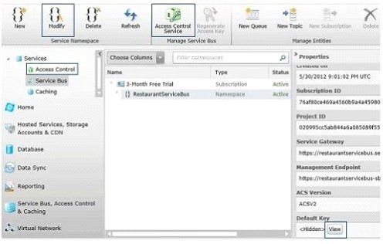

## Answer:

**QUESTION 96**

Drag and Drop Question

You are developing an ASP.NET MVC Web API application. The methods of the Web API must return details about the result of the operation. You need to create a method to add products. You have the following code:

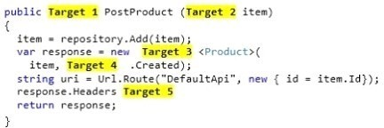

Which code segments should you include in Target 1, Target 2, Target 3, Target 4 and Target 5 to complete the code? (To answer, drag the appropriate code segments to the correct targets in the answer area. Each code segment may be used once, more than once, or not at all. You may need to drag the split bar between panes or scroll to view content.)

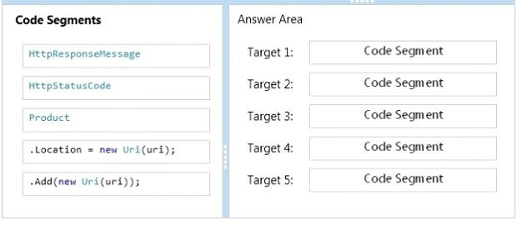

## Answer:

**QUESTION 97**

You are developing a .NET application that uses the HttpClient type to call an ASP.NET Web API application. The API call returns a list of customers in JSON format and logs the results. The URI for the API call is in a variable named address. You need to make the API call without blocking. Which code segment should you use?

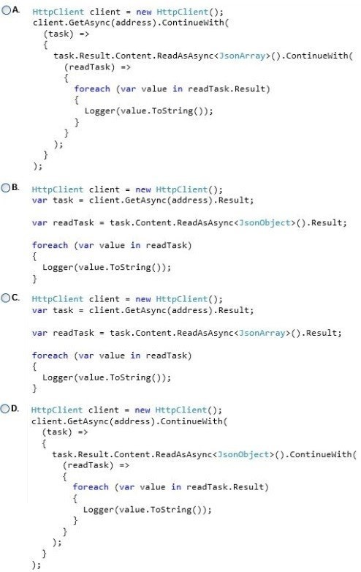

|  |  |
| --- | --- |
| A. | Option A |
| B. | Option B |

|  |  |
| --- | --- |
| C. | Option C |
| D. | Option D |

## Answer:

**QUESTION 98**

Drag and Drop Question

You are developing a .NET application that uses the HttpClient type to access an ASP.NET Web API application. You need to add a header to specify that data is returned as JSON. You have the following code:



Which code segments should you include in Target 1 and Target 2 to complete the code? (To answer, drag the appropriate code segments to the correct targets in the answer area. Each code segment may be used once, more than once, or not at all. You may need to drag the split bar between panes or scroll to view content.)

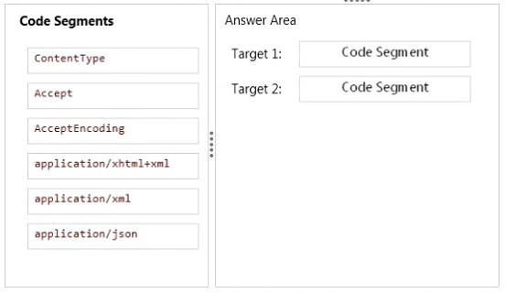

## Answer:

**QUESTION 99**

Hotspot Question

You are updating an existing multitenant ASP.NET MVC application for medical clinics. The application aggressively uses output caching to improve performance by caching content for 36 hours. The application uses a query string parameter named "clinicID" that contains the clinic that the user is currently viewing. Users report that they are occasionally seeing data for the wrong clinic. Users also report that sensitive data is stored in the browser cache folder on their computers. You need to configure web.config to resolve the reported problems. You have the following markup:

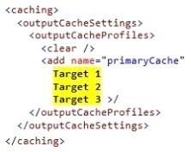

Which markup segments should you include in Target 1, Target 2 and Target 3 to complete the markup? (To answer, select the correct markup segment from each drop-down list in the answer area.)

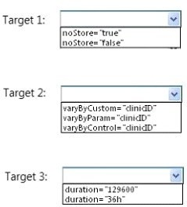

## Answer:

**QUESTION 100**

Drag and Drop Question

You have a UI element library. You need to build a NuGet package to integrate the library into your projects. What should you do? (To answer, drag the appropriate code elements to the correct location or locations in the answer area. Each code element may be used once, more than once, or not at all. You may need to drag the split bar between panes or scroll to view content.)

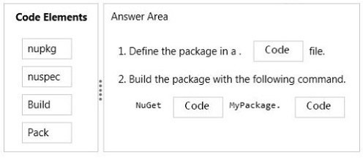

## Answer:

### QUESTION 101

Hotspot Question

You are developing a WCF service. The service must be interoperable with ASP.NET web service clients. In addition, it must have a time-out of three hours. You need to configure the service to meet the requirements. You have the following markup:

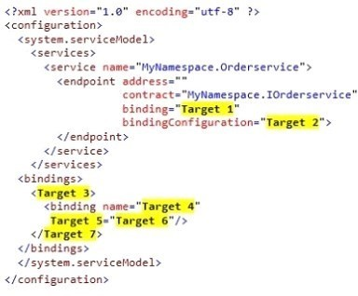

Which markup segments should you include in Target 1, Target 2, Target 3, Target 4, Target 5, Target 6 and Target 7 to complete the markup? (To answer, select the appropriate markup segment from each drop-down list in the answer area.)

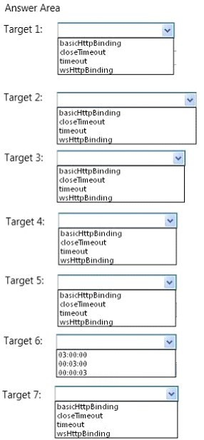

### Answer:

**QUESTION 102**

Drag and Drop Question

You are configuring a web application for deployment. You need to create a SetParameters.xml file to configure the IIS application pool. You have the following markup:

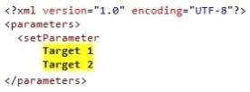

Which configuration values should you include in Target 1 and Target 2 to complete the markup? (To answer, drag the appropriate configuration values to the correct targets in the answer area. Each configuration value may be used once, more than once, or not at all. You may need to drag

the split bar between panes or scroll to view content.)

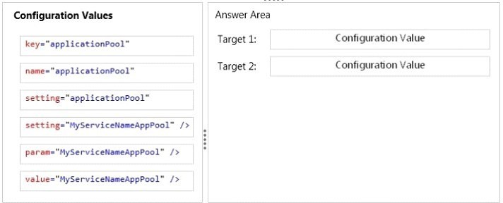

### Answer:

**QUESTION 103**

You are developing an ASP.NET MVC application. The application has a page that updates an image stored in a database. Members of the EntityClient namespace are used to access an ADO.NET Entity Framework data model. Images and associated metadata are stored in a single database table. You need to run a single query that updates an image and associated metadata in the database while returning only the number of affected rows. Which method of the EntityCommand type should you use?

|  |  |
| --- | --- |
| A. | ExecuteNonQuery() |
| B. | ExecutcScalar() |
| C. | ExecuteDbDataReader() |
| D. | ExecuteReader() |

### Answer:

**QUESTION 104**

You are developing a new ASP.NET MVC application that does not have an existing database. The requirements for the application are not complete, and the SQL data model will likely change. You need to choose an approach to visually manage a data model. Which approach should you

use?

|  |  |
| --- | --- |
| A. | Physical First |
| B. | Database First |
| C. | Code First |
| D. | Model First |

### Answer:

### QUESTION 105

You are preparing to develop a set of libraries that uses large data sets. The libraries must be shared across an organization and distributed to several servers. You need to create a remote NuGet feed that exposes the libraries for developer use. What should you do? (Each answer presents part of the solution. Choose all that apply.)

|  |  |
| --- | --- |
| A. | Add packages to the Packages folder. |
| B. | Create a new Empty Web Application in Visual Studio. |
| C. | Configure the Packages folder located in the appSettings section of the web application's Web.config. |
| D. | Install the NuGet.DataFeed Package. |
| E. | Install the NuGet.Server Package. |
| F. | Create a new Empty Web Site in Visual Studio. |

**Answer:**

**QUESTION 106**

Drag and Drop Question

You are supporting a WCF data contract that returns a price calculation that can be expanded to add new data members. Clients using the old version of the data contract must be supported. You need to define the data contract so that the data serializer can put unknown data members into a property bag. You have the following code:

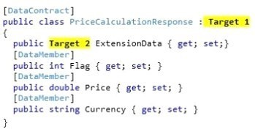

Which code segments should you include in Target 1 and Target 2 to complete the data contract? (To answer, drag the appropriate code elements to the correct targets in the answer area. Each code element may be used once, more than once, or not at all. You may need to drag the split bar

between panes or scroll to view content.)

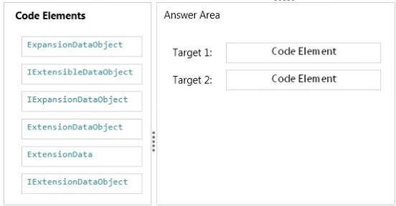

### Answer:

**QUESTION 107**

You are developing an ASP.NET MVC application that reads and writes data from a SQL Server database. You need to maintain data integrity including retrieving identical sets across reads in all situations that use transactions. Which isolation level should you use?

|  |  |
| --- | --- |
| A. | Repeatable |
| B. | Serializable |
| C. | ReadUncommitted |
| D. | ReadCommitted |

### Answer:

### QUESTION 108

You are developing an ASP.NET MVC web application in Visual Studio 2012. The application requires several thousand content files. All content is hosted on the same IIS instance as the application. You detect performance issues when the application starts. You need to resolve the performance issues. What should you do?

|  |  |
| --- | --- |
| A. | Implement HTTP caching in the ASP.NET MVC controllers. |
| B. | Combine the content files by using ASP.NET MVC bundling. |
| C. | Install a second IIS instance. |
| D. | Move the content to a Windows Azure CDN. |

### Answer:

**QUESTION 109**

You are testing an ASP.NET application. The test plan requires that tests run against the application's business layer. You need to use the test project template that meets this requirement. Which template should you use?

|  |  |
| --- | --- |
| A. | Web Test Project |
| B. | Load Test Project |
| C. | Unit Test Project |
| D. | Coded Test Project |

### Answer: 3

[**Visit PassLeader and Download Full Version 70-487 Exam Dumps**](http://www.passleader.com/70-487.html)